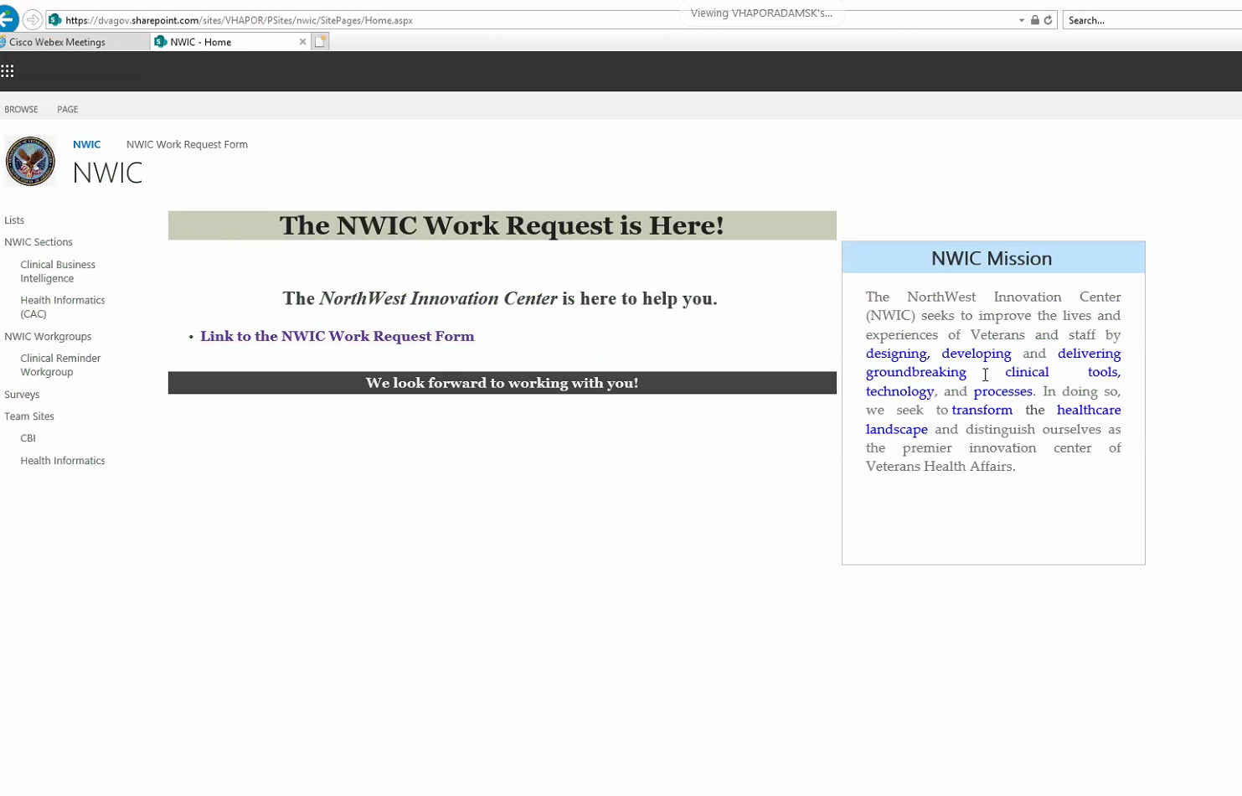

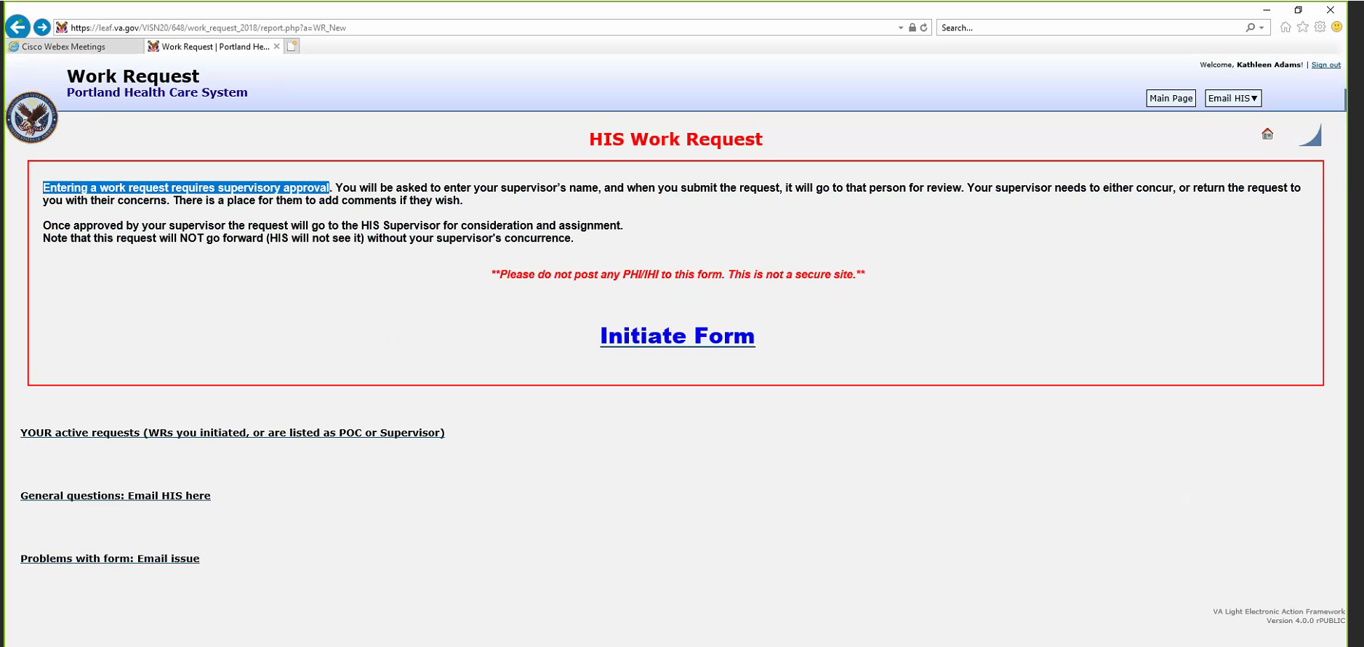

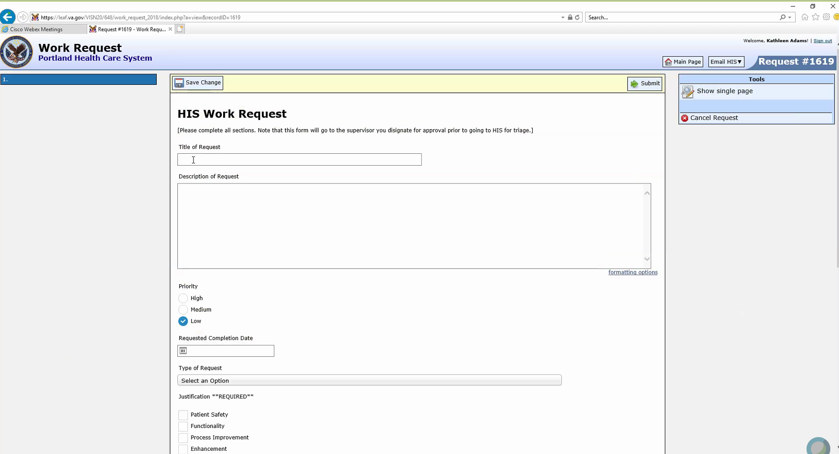

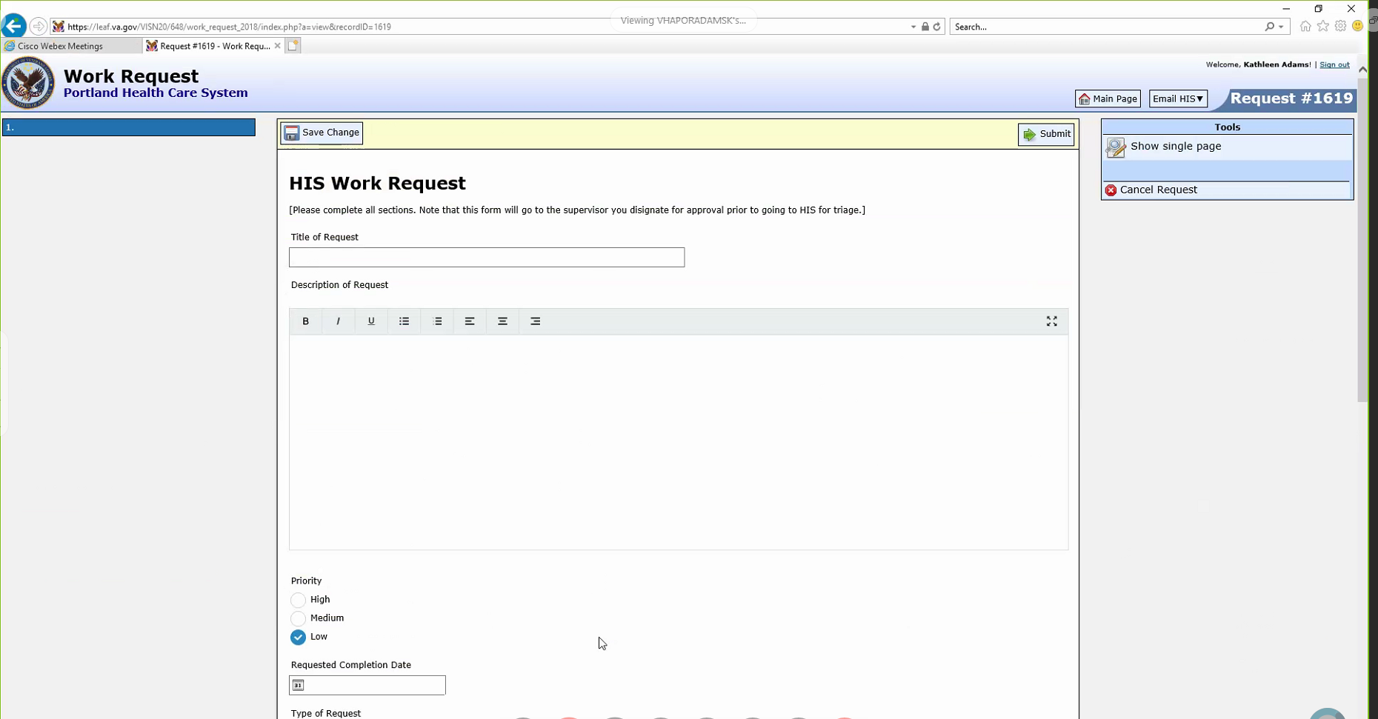

These forms are also used for work management. Also share management links break.

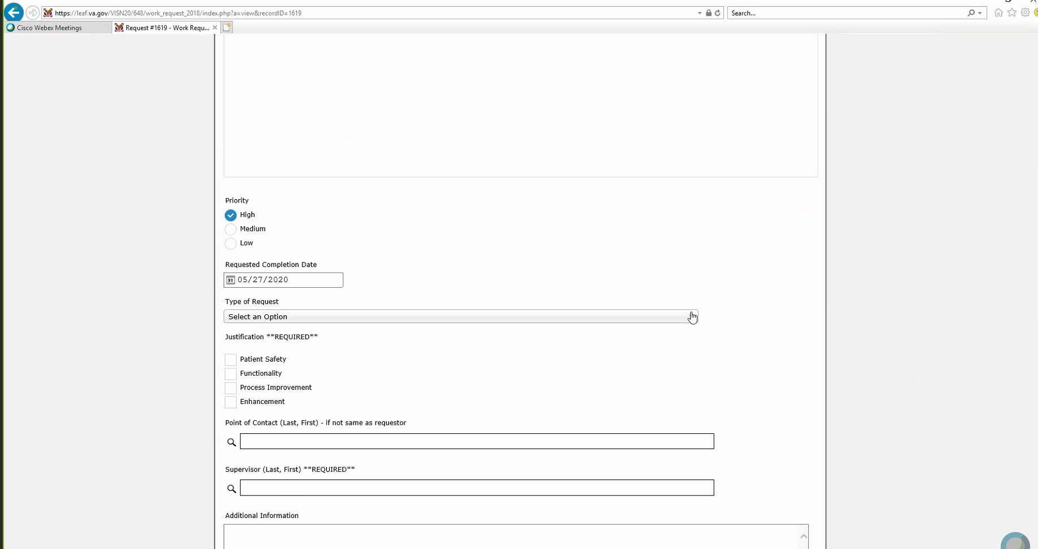

I need keys to schedule consults. All access is to the system, not access to care. In anyrole, you get keys for each person . CACs have more keys than Kas. Kas cannot schedule. Every 6 months this is reviewed.

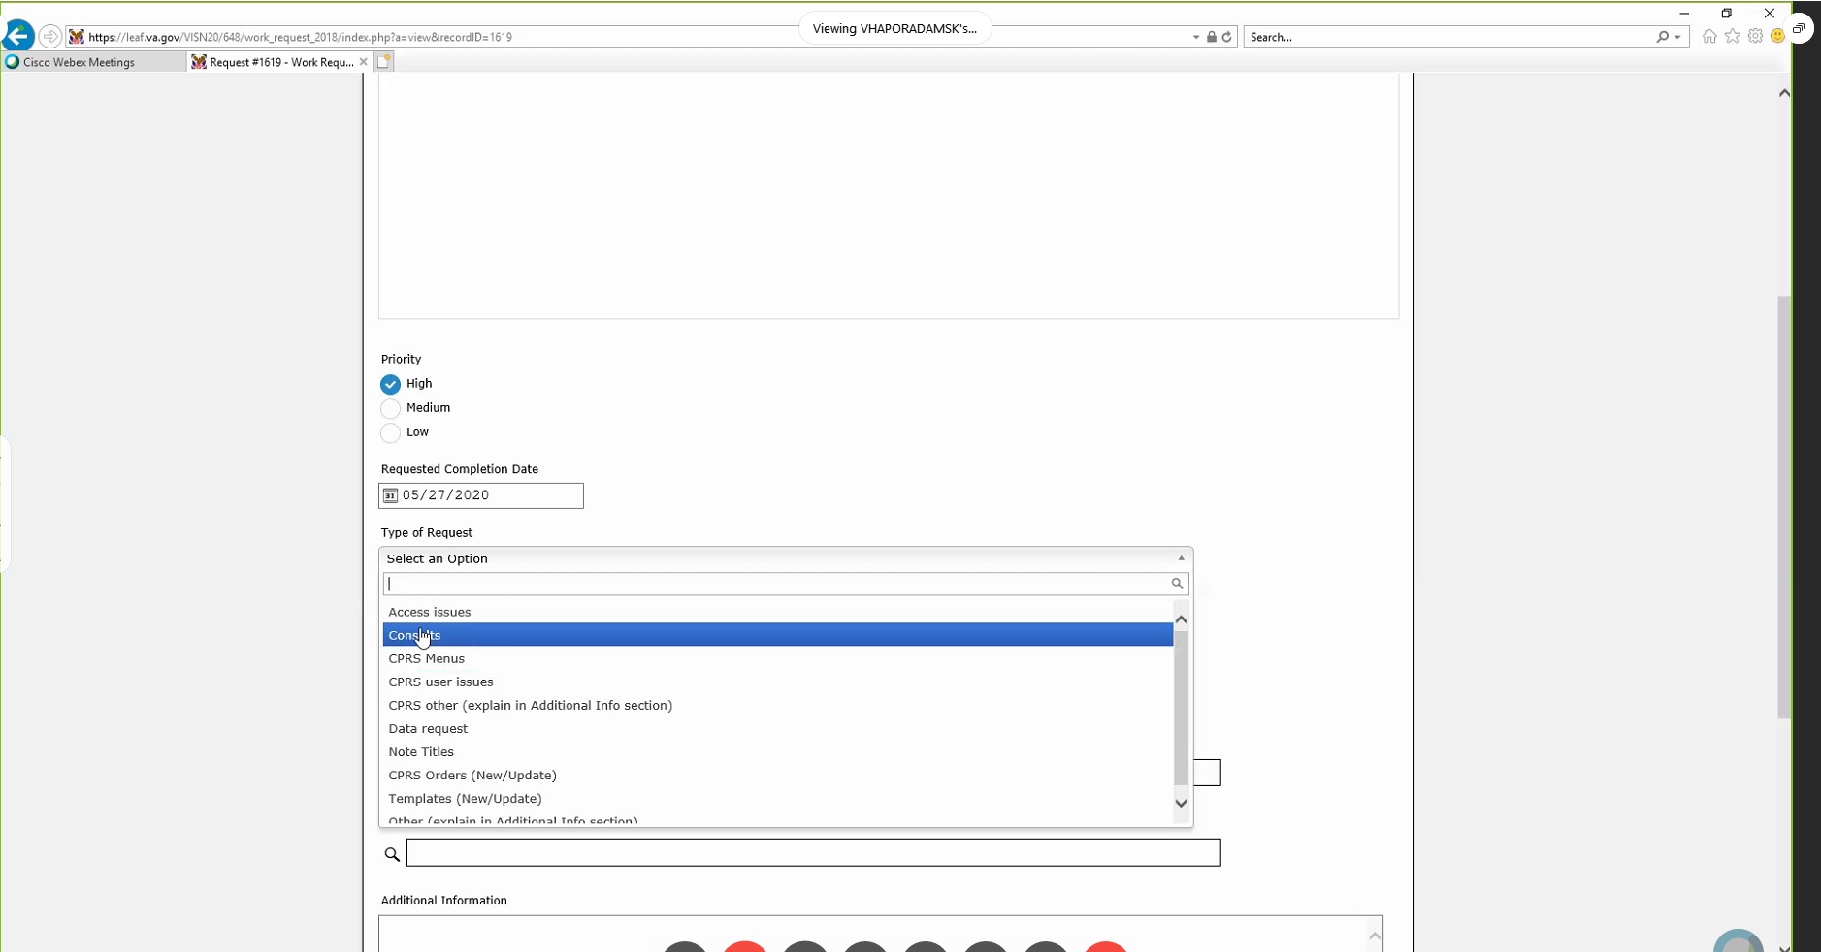

Schedule consults for outside hcp

CPRS menu new stuff to build

User issues – cannot schedule

Other – want to be able to program in cprs, no

Data request

**Data request:** CACs must run the reports, not NWIC. NWIC used to do this, but now dismantling it. Data analysts in each department now will do this.Clinical business intelligence. Used to have 10, now only a supervisor.

Only the people with informaticist – only if they have a degree in it. May be certified. Kas is, but not all of them are. Most have a clinical degree. 150 fellows that got recognized. No

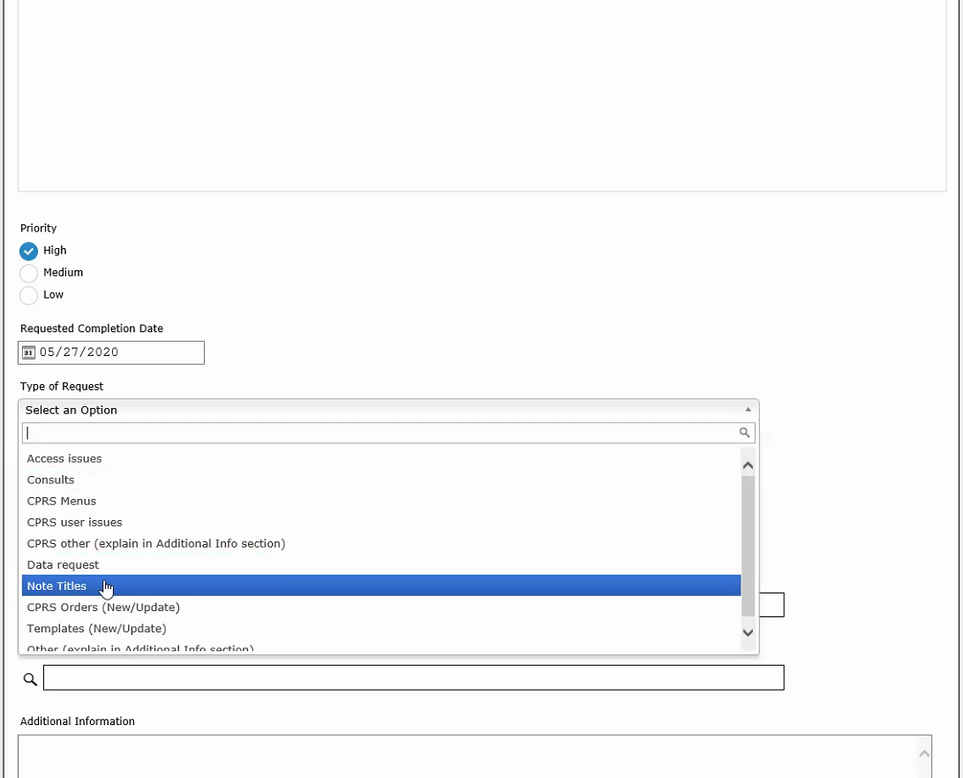

CACs do note titles.

Change guard rails for dosing, no longer use morphine That falls under orders.

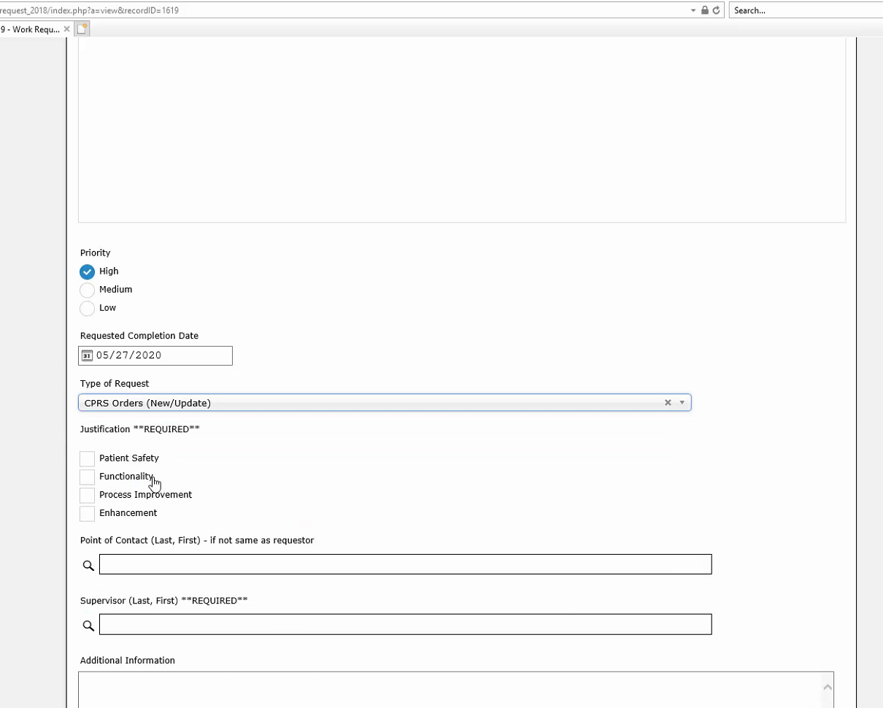

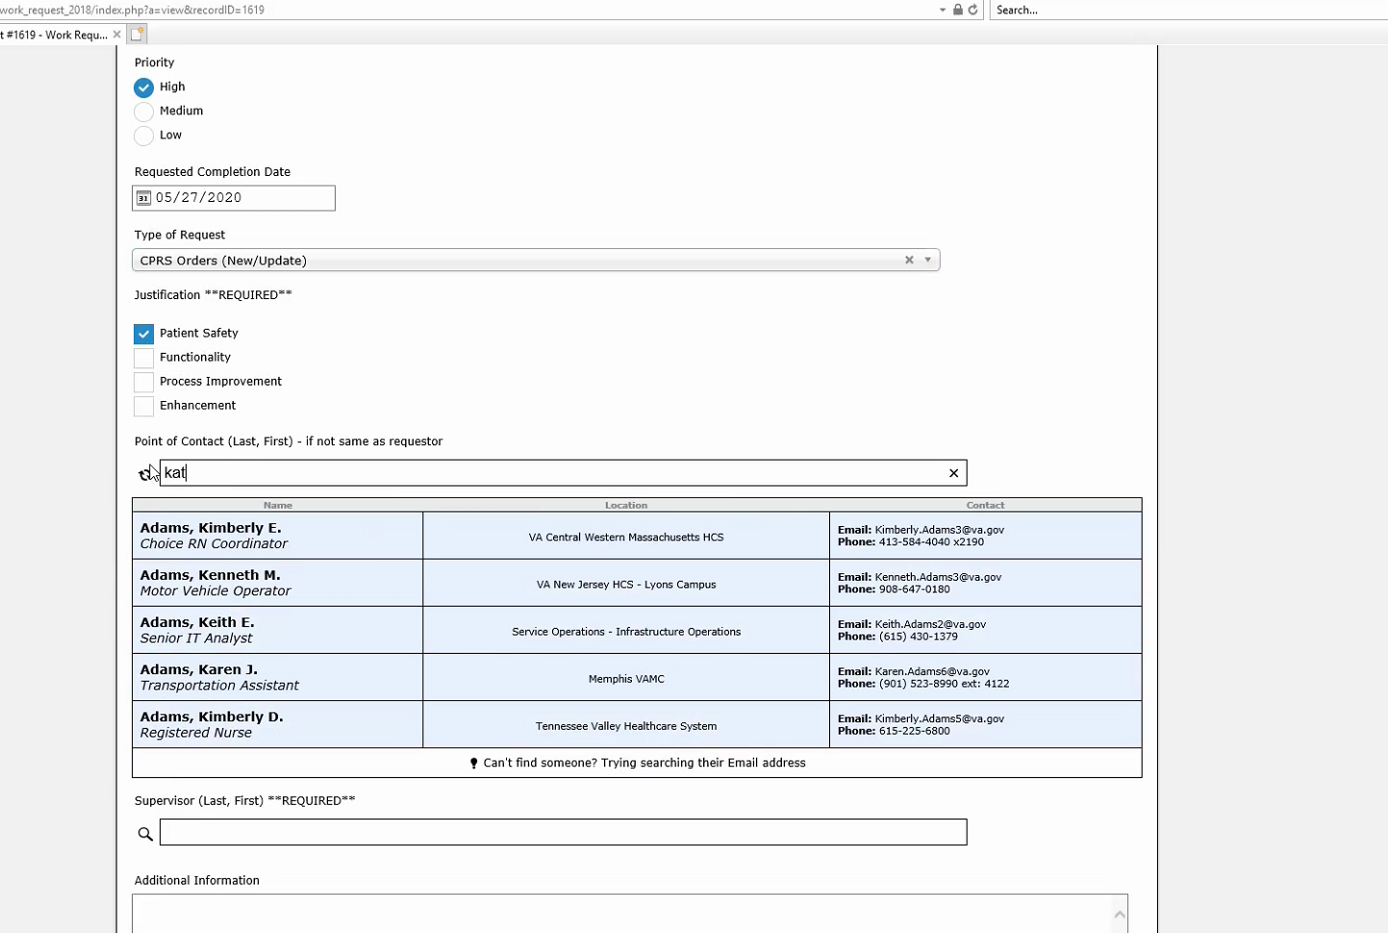

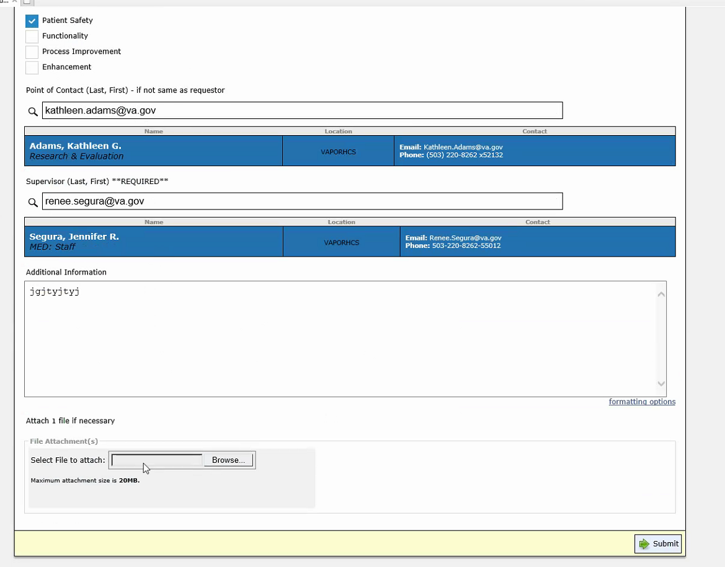

Then they get triaged to the people who specialize in each area. After submitted, request number assigned, then goes to the supervisor, then they agree. Then it moves on.

**Future: Post Cerner**

What will the CACs role is be after being trained. Learn a lot of new stuff. Some CACs will retire. May only want to do CPRS vista, will go somewhere else. May be a bridge so that when Cerner comes it won’t break.

The CACs will move to another department Portland is 5th to get Cerner,

Cerner implementation is going to force standardization to the VA. 150 plus sites had a different way to manage diabetes. Now one way.

Cerner wants people with an eye towards effectiveness, safety and efficiency. Just a sniff test. A way to report that up to the chain.